|  |  |  |  |  |  |  |  |  |  |  |  |  |  |  |
| --- | --- | --- | --- | --- | --- | --- | --- | --- | --- | --- | --- | --- | --- | --- |
| **MAD Project Evaluation 2 – June Intake 2022** | | | | | | | | | | | | | | |
| **Project Name:** |  | | **Batch:** |  | | | |  |  |  |  | | |
| Student ID | Student Name | Integrated system using a repository (Out of 5) | Marketing the app using a video clip published in a social media account (eg: LinkedIn) (Out of 10) | CRUD Function completeness (Out of 20) | Database connectivity (Out of 5) | Usability (Out of 5) | Validations (Out of 5) | Good coding practice (Out of 5) | Out of box features (Out of 10) | Test cases (Out of 10) | Report (Out of 10) | Q & A (Out of 15) | Total (Out of 100) |
| IT20624330 | Premathilaka M.A.D.M. |  |  |  |  |  |  |  |  |  |  |  |  |
| IT20615048 | Rasanjali P.G.K. |  |  |  |  |  |  |  |  |  |  |
| IT20298258 | Jayamanna H.E. |  |  |  |  |  |  |  |  |  |  |
| IT20614980 | Thennakoon T.M.S.K.S. |  |  |  |  |  |  |  |  |  |  |
|  |  |  |  |  |  |  |  |  |  |  |  |

Git Repository Link: https://github.com/IT20624330/MAD_Project.git ………………………………………………………………………………………………………………………………………………………………………………………………..

Link for the video in social media: ……https://m.facebook.com/story.php?story_fbid=468755588356165&id=100056651834969…

https://www.linkedin.com/posts/dinusha-premathilaka-962ba8215_androiddevelopment-android-development-activity-6930355386377977856--JTU?utm_source=linkedin_share&utm_medium=member_desktop_web………………………………………………………………………………………………………………………………………………………………

(All group members must be tagged)

----------------------------------------------------------------------------------------------------------For Evaluators---------------------------------------------------------------------------------------------------------

Evaluator’s name: Comments:



**Mobile Application Development – IT2010**

***Code Killers***

Day by day online food ordering system has become an indispensable necessity in whole of the world. Many people who lead busy lives are very much inclined towards food ordering systems through the online. And the other hand sometimes people are going to the restaurant at the times tables may be unavailable. As same as if the people want to celebrate some special occasions in the same restaurant table can be unavailable and at the same time cannot be book the table also on another restaurant due to the time. As a result of those things people’s plan going to be breakup. And mood become off mood and turn in to bad temper due to all of that reasons. So that, online food ordering system become an option for aware from those problems. “**Tasty Kingdom”** is an online food delivery system in Sri Lanka. We are not an option to you, we are the solution to you. Up to 10 years we prove it via offline now we are ready to prove that via online also. Our purpose is provide the customers to order and have, fresh and quality food on their doorstep. And the other hand we provide you table booking system for come and have you meals on your favorite shop without wasting time. And also you can add your comments on the feedback forum. In the offers page you can see monthly offers we are providing you. As same as no worries if customer cannot come to take the order, we give them our delivery facility. We allows customers to order the food with an affordable price. Using card payment customer can complete their payments via online. We have Breakfast, Lunch, Dinner, dessert and Beverages on our menu. We are always available whenever the customer need our service. So feel to free contact us. The users of this app can able to create, read, update and delete according to their desires.

***Branch Details***

|  |  |  |  |
| --- | --- | --- | --- |
| **Registration Number** | **Student Name** | **Branch Name** | **Username** |
| IT20624330 | Premathilaka M.A.D.M. | Dinusha Premathilaka | IT20624330 |
| IT20615048 | Rasanjali P.G.K. | Kavindi Rasanjali | KavindiRasanjali |
| IT20298258 | Jayamanna H.E. | Hiruni Jayamanna | IT20298258 |
| IT20614980 | Thennakoon T.M.S.K.S. | Kavinda Thennakoon | IT20614980 |

***Snapshot of GitHub repository contribution graph and commit lists.***

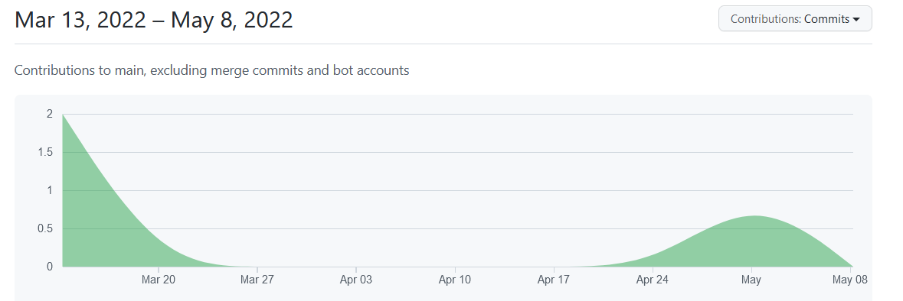

***Individual Contribution***

**Registration No : IT20624330 – Premathilaka M.A.D.M**

* **Booking Table**
* Create, delete table booking details
* Read / view and update table booking details.

**Registration No : IT20615048– Rasanjali P.G.K.**

* **Payment Management**
* Create, Update, Delete payments.
* Display payment history and card info

**Registration No : IT20298258- Jayamanna H.E.**

* **Delivery Management**
  + Create, Update, and Delete delivery details (with Admin privileges)
  + Display details.

**Registration No : IT20614980 – Thennakoon T.M.S.K.S.**

* **Add Food Items**
  + Create, delete food items details(with Admin privileges)
* Read / view and update food items details.

***Equal Contribution***

Login , Register, Home